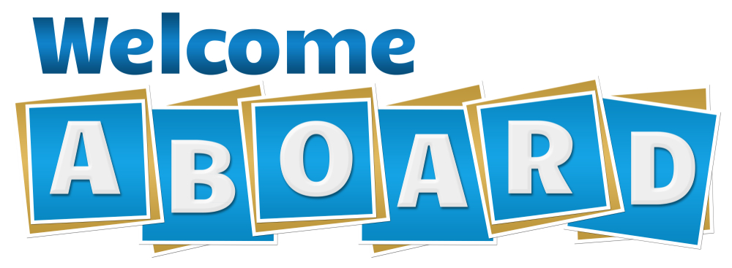

Stage Your New Hire Training Plan to Gain Incremental Success
We read often “A Best Practice: Be sure to have a Plan for your new hire’s orientation and onboarding.” This is TRUE.
A wise leader will map a plan that is staged and builds incremental skills.
Stage the learning plan to include incremental and purposeful learning that carries an immediate impact. Statistics show that continual learning will increase new hire retention considerably.
A solid training program for new hires includes education, experience and exposure.
- Start with the Basics! You hired a talented individual who is “brand new” to insurance. Create a continuous and cumulative education path to gain new knowledge and practical skills that can be immediately applied in their role.
The most important thing you can do is to “avoid the firehose” technique. This is when you push the new hire into a multi-week producer school or program immediately, load up lots of reading material in all modes and pack the days with “filler” activities.
Create an incremental plan that taps into a variety of learning resources. Space and vary the learning interactions including online, real-human interactions, hands-on accountable responsibilities, etc.
- Map a gradual plan of smaller hurdles at first and that lead to a longer or more detailed education and experience. Correlate new information to application of skills and knowledge.

The reality is that onboarding should be staged for a period of one year. This is not related to the new hire’s capabilities to perform “real work.” Staging or phasing in essential skill-based and process training should correlate to job functions that carry immediate impact and are essential functions of the individual’s role.

- Incorporate Customer-Ready Activities (immediately). Whether the new hire has their license or is currently studying, they can still impact customers in a variety of ways.

Create significant activities where they can gain exposure. For example, accompany producers on client meetings, analyze monthly renewals with alignment to a questionnaire, review agency inbound inquiries to understand the client’s voice and needs, identify coverage gaps on various account reviews, etc.

Help the new team member build confidence from Day One:
Reinforce Progress and Reward Positive Impact.

Need Help with New Hire Training? Visit www.myagencycampus.com.

